**Project Work Progress Report No 2**

Date: 02/23/2019 Team #: 33

Project Title: Anti-theft Package Security Home System (APSHS)

Submitted by Gregory Escobar, Stephen Benavides, Shawn Carnevale, Geomar Reyes

1. Project progress since last report:

**Gregory Escobar and Shawn Carnevlale:**

This is an updated version of the schematic for the whole project

**Communication between ESP32S and Adafruit PN532**

Our team is still working to stablish communication between the ESP32-WROOM-32 and the PN532 using I2C communication protocol.

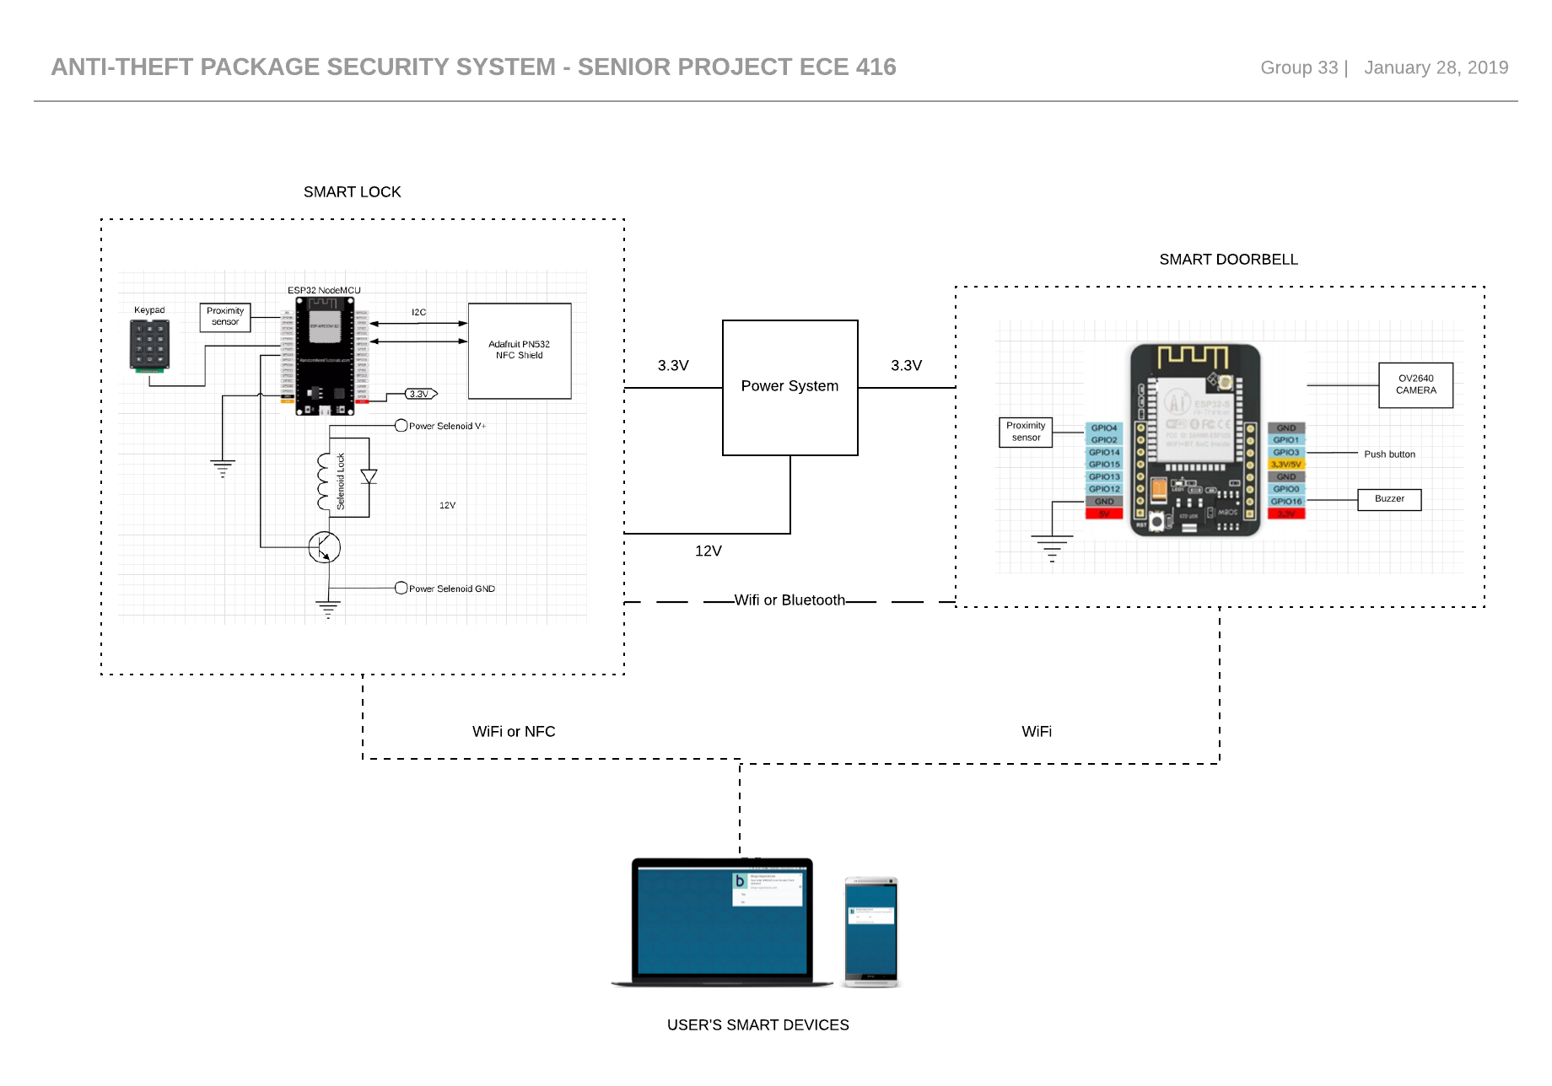

Figure 1 Anti-theft package Security System

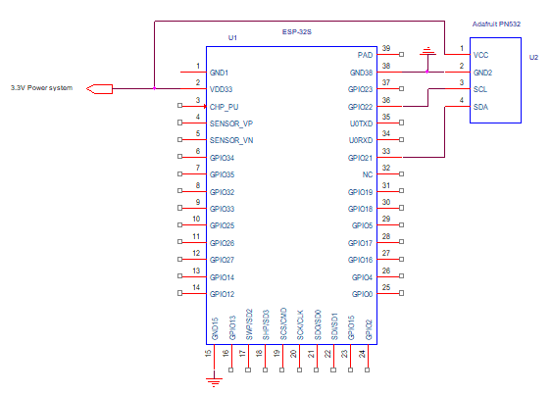

Figure 2 ESP32S and PN532 i2C wiring guide

**Power System**

For the power system our team have just picked out and received some new equipment. The focus this week was to find a way to charge and discharge the battery to and to keep a steady voltage because most of our components operate between 3.3-5 volts. The main issue was to design something that was simple and to keep it as affordable as possible. We found the solution of how to do that with a single component which was affordable and met our needs and specifications. Next week the goal will be to do more schematic work to finalize the design so we can move forward to start to build our power system onto a breadboard.

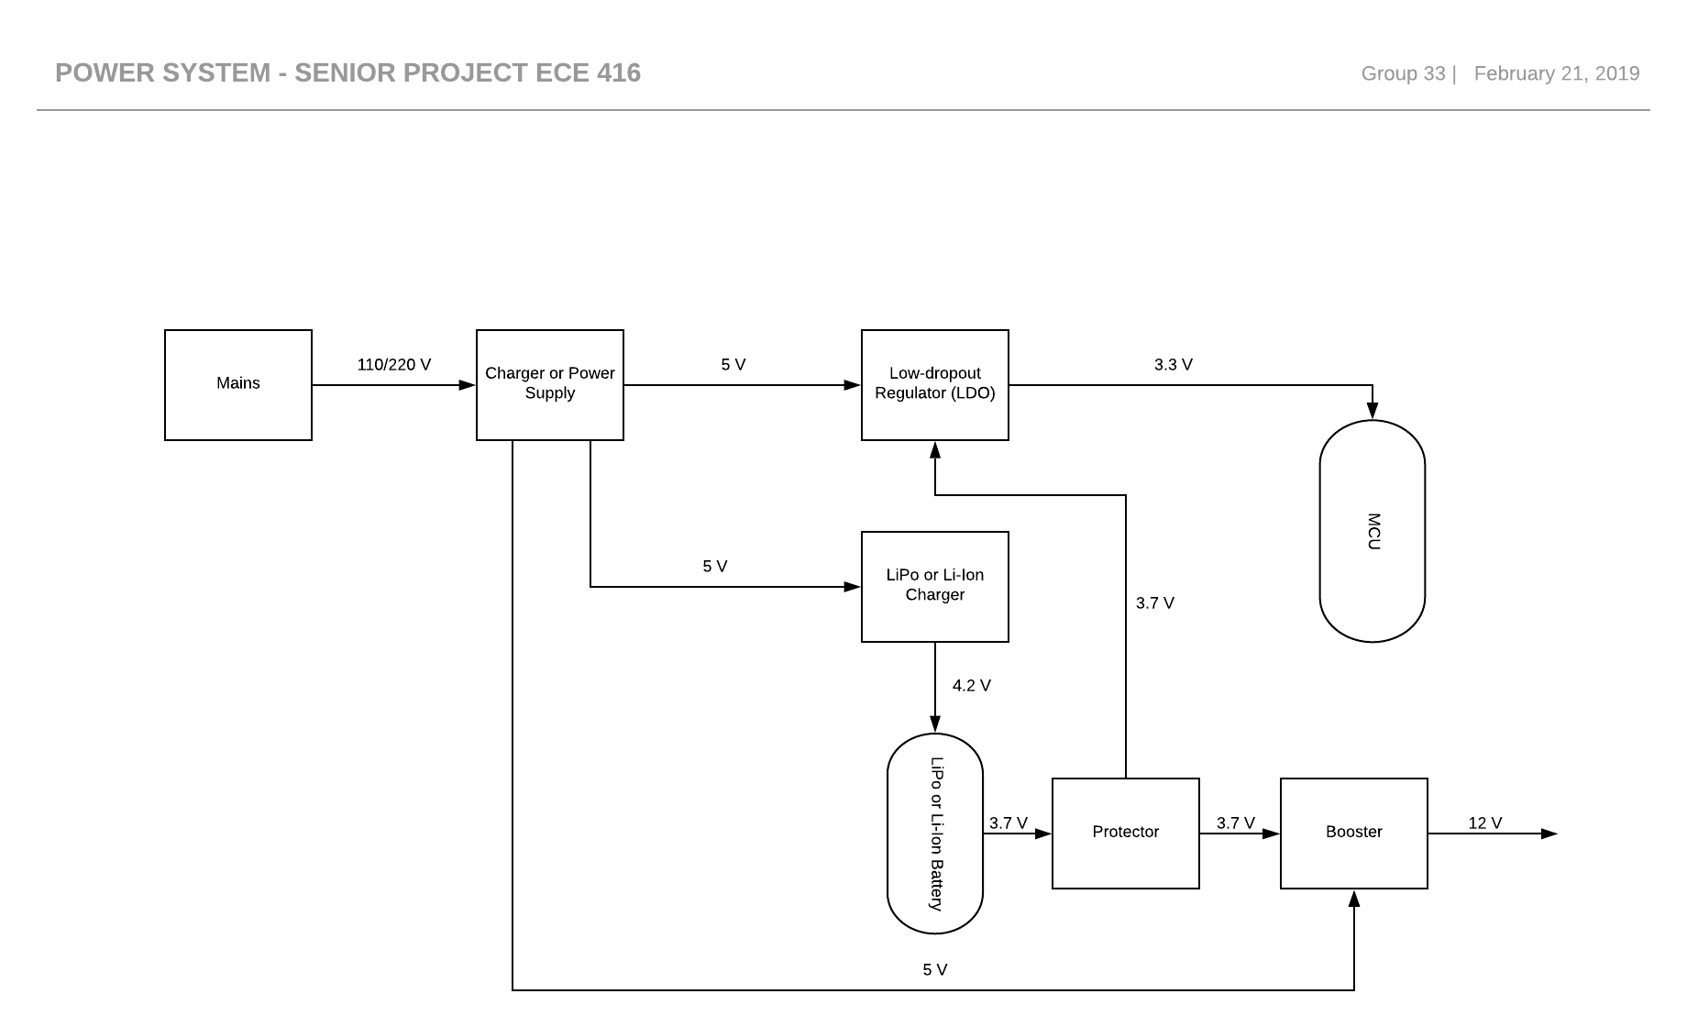

Figure 3 Power System

**Stephen Benavides:**

Our goal this week is to be able to connect the ESP32 to a LAN network and establish a control point for all the incoming connection using a cellphone as the router.

We were able to find the ESP32-WROOM-32D MCU IP address within the Arduino IDE serial monitor, now we are trying to send a pin signal to the computer wirelessly from the ESP32-WROOM-32D MCU.

I wanted to add Wireshark to our operations, but it might not be necessary yet. It is used for troubleshooting and diagnostic of the networks, this will be useful when trying the use the UART protocols to connect online using the web app to see if there are any problem with the connection.

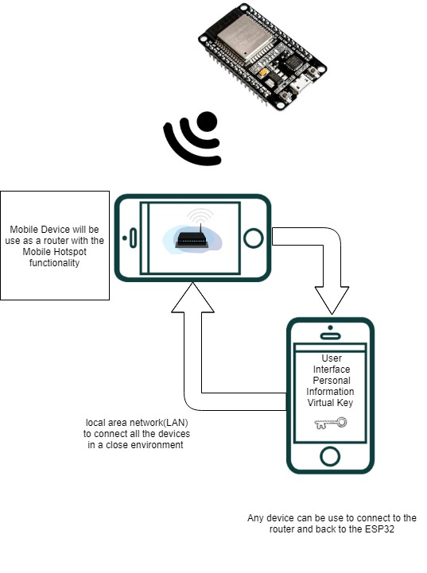

Figure 4. ESP32 connected to network

**Geomar A. Reyes**

Our goal for this week is to make the login page of the android app functional so that we can start to put name of customer and their ID in to a data base that will be connected to the app. This app will ask for a person username which will be provided by an administrator and the password will be made by the customer. The login screen will be able to match the username and password input by the customer with the one in the database.

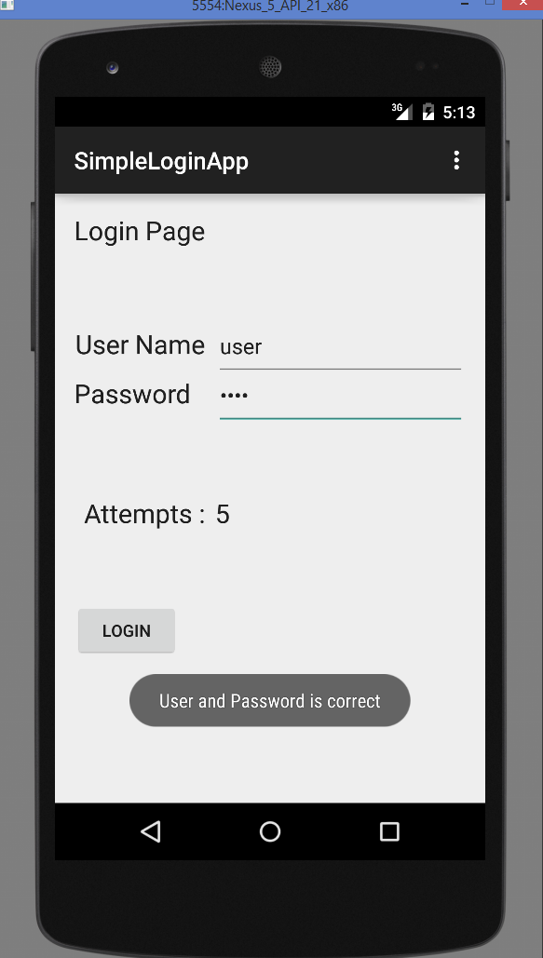

Figure 5. APP login screen

1. Milestones achieved:

* Power System design was finalized by Shawn Carnevale and Gregory Escobar 02/21/19
* Wireless connection stablished between the ESP32-WROOM-32D MCU and the computer finalized by Stephen Benavides. 02/21/19
* Finish the login screen of the android app and database system by Geomar Reyes 02/21/2019.

1. Problems and roadblocks, if any:
2. Is project on schedule? YES__X___ NO____
3. Next steps: (elaborate specifically on any problems listed in 3 and if the answer in 4. Is NO) (You may use more pages, if needed)